Project Document
Intro to se: dr. nada hany and eng. nada elsayed

sherif Hany 232000439
Ali Hossam 231003072
abdelrahman Mohammed 231011618

Software Project Document
Functional Requirements:
1. The system should allow admin users to securely login to the system to ensure access control.
2. The system should display a list of all existing content categories.
3. The system should allow the creation of new content categories with a unique code and a description.
4. The system should allow editing of category descriptions with a confirmation prompt before changes are saved.
5. The system should assign digital content items (by Content ID) to a selected category.
6. The system should display the details of a content item before confirming its assignment to a category.
7. The system should not allow deletion of content categories to maintain data integrity.
8. The system should generate reports based on category assignments and sales data.
Non-Functional Requirements:
- User-Friendly Interface (Clear Prompts and Feedback)
Requirement: The system must provide intuitive and clear screens with prompts and feedback, ensuring that marketing staff (e.g., Penelope, Matilda, Raquel) can easily navigate functions like managing content categories, assigning users, and generating reports without extensive training.
- High Reliability (Correct Handling of Data and Transactions)
Requirement: The system must reliably process user actions (e.g., assigning content items to categories, updating descriptions) without data loss or corruption, even under concurrent usage.
- Secure Access (Login-Based)
Requirement: Access to the system must be controlled via secure login credentials to prevent unauthorized access to sensitive marketing data.
- Performance Efficiency (Large Data Volumes)
Requirement: The system should perform well with large volumes of content and user data, ensuring quick response times for operations like generating summary reports.
- Scalability (Support Future Growth)
Requirement: The system design should allow for the easy addition of new content categories, audience segments, and users as the company grows.
- Maintainability (Easy Updates and Enhancements)
Requirement: The system’s architecture should facilitate easy maintenance and the addition of new features, ensuring long-term sustainability.
- Consistency and Data Integrity (Accurate Category Assignments)
Requirement: The system must ensure that all data (e.g., category assignments, segment assignments) remains consistent and free from duplication or corruption.
- Proper Error Handling (Invalid Input, Duplicate Codes, etc.)
Requirement: The system must handle errors gracefully, providing clear messages when users input invalid data or attempt to use duplicate codes.
Use Case Diagram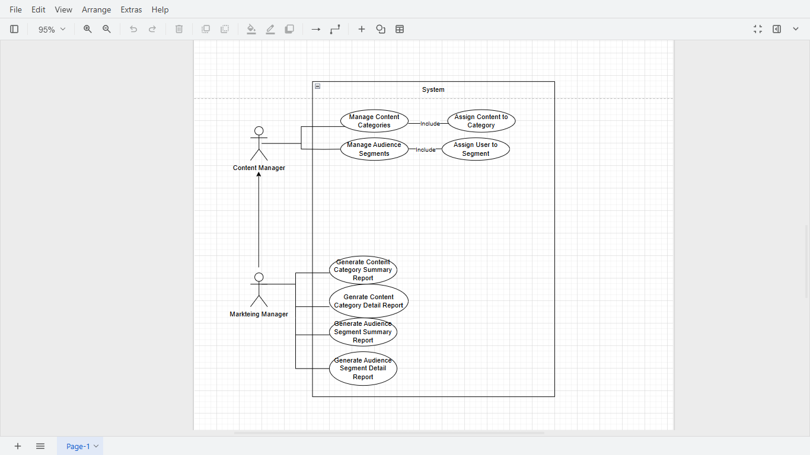State Chart Diagram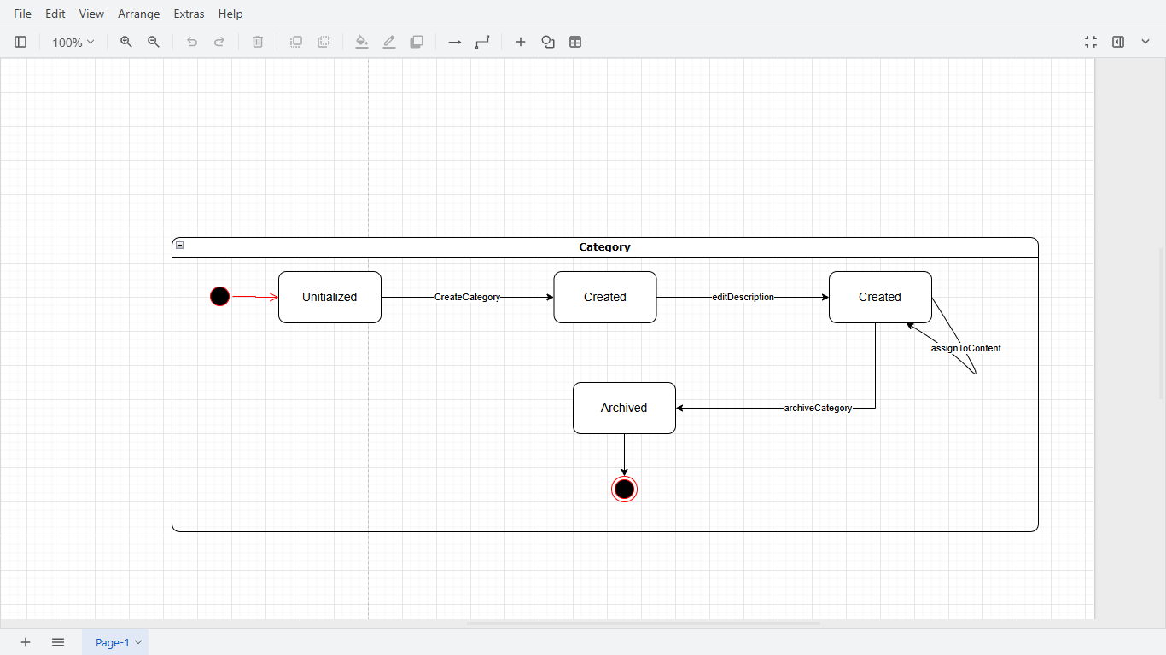Class Diagram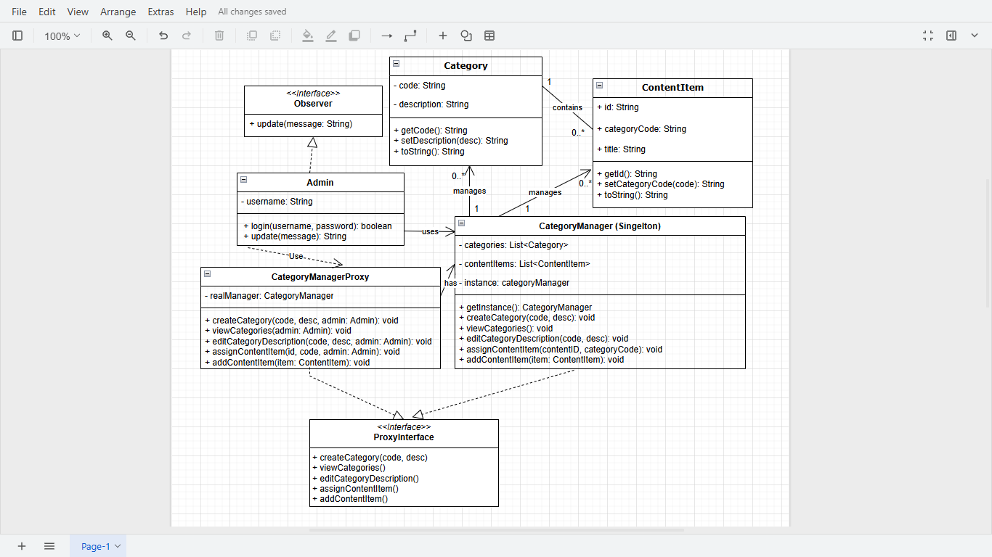Activity Diagram 1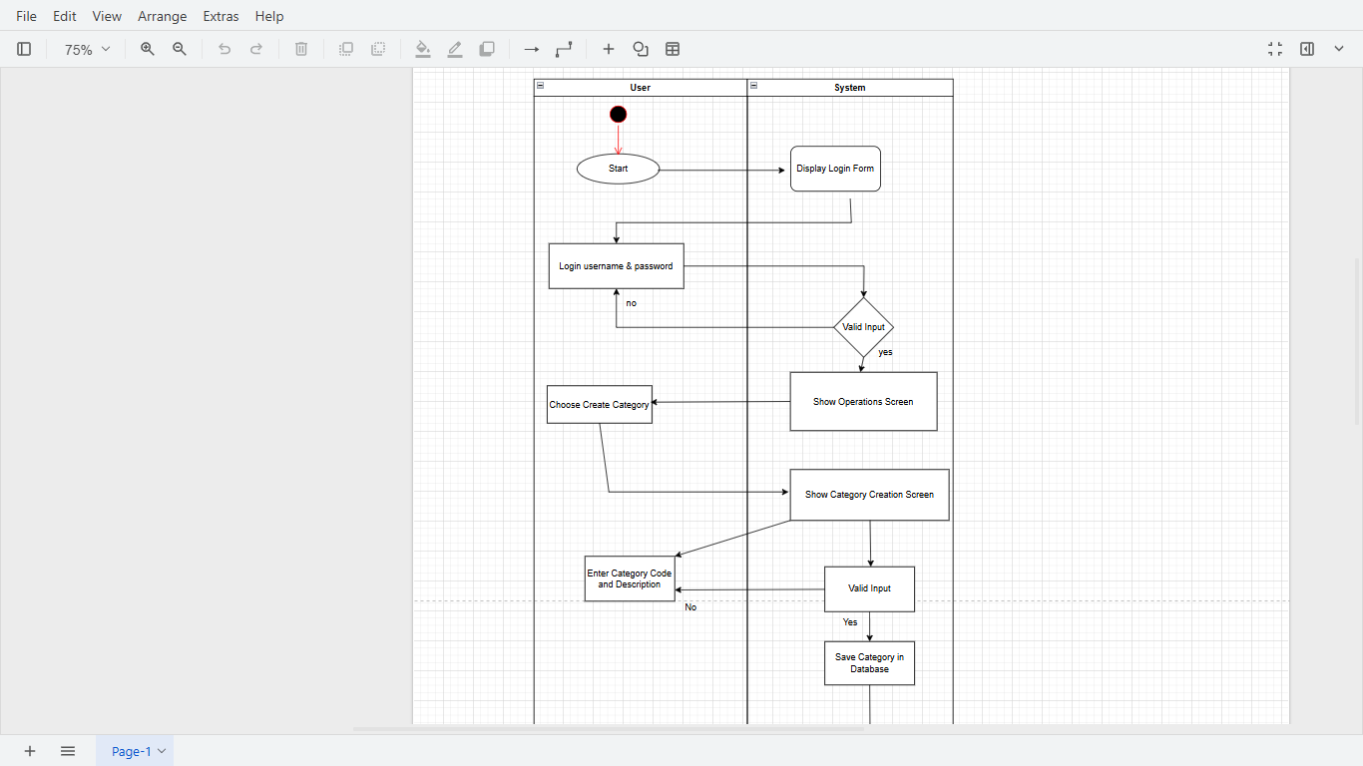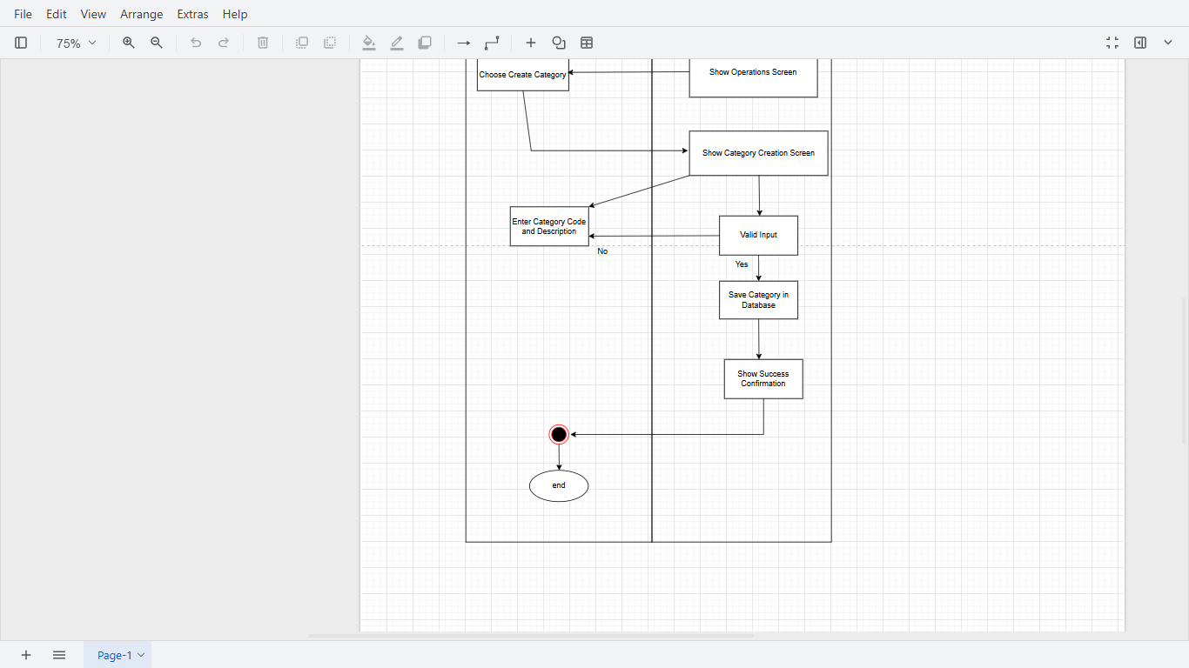Activity Diagram 2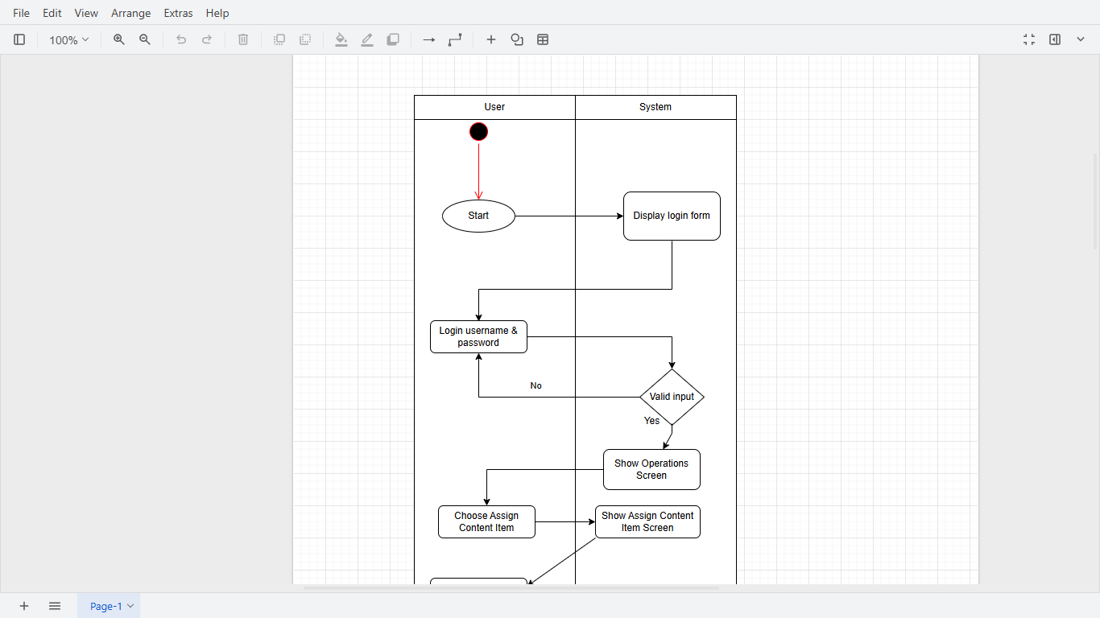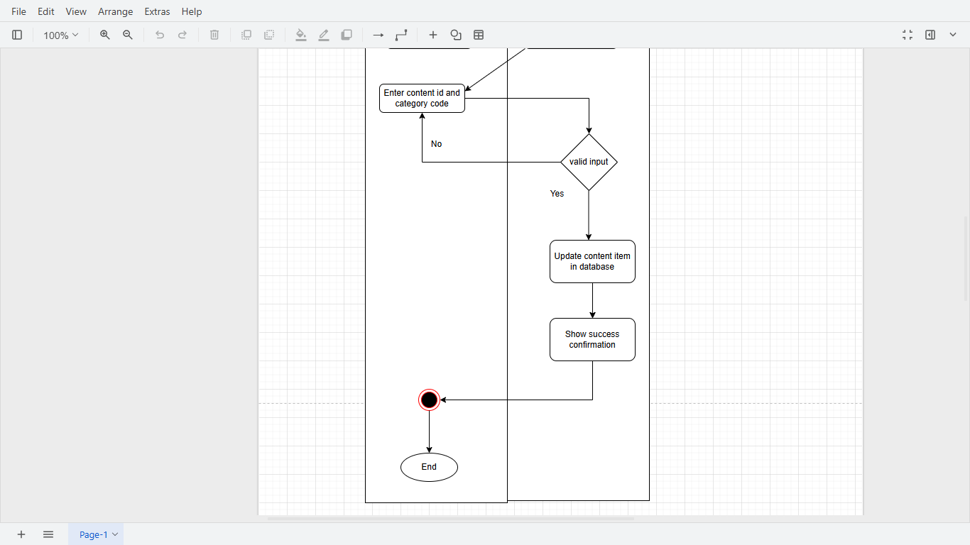Sequence Diagram 1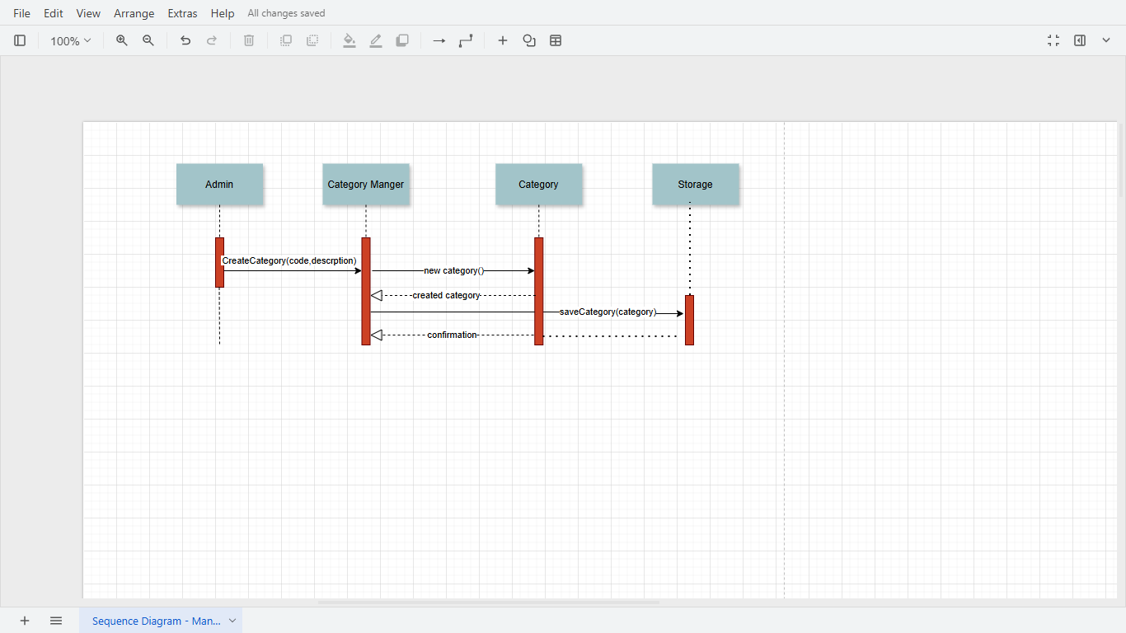Sequence Diagram 2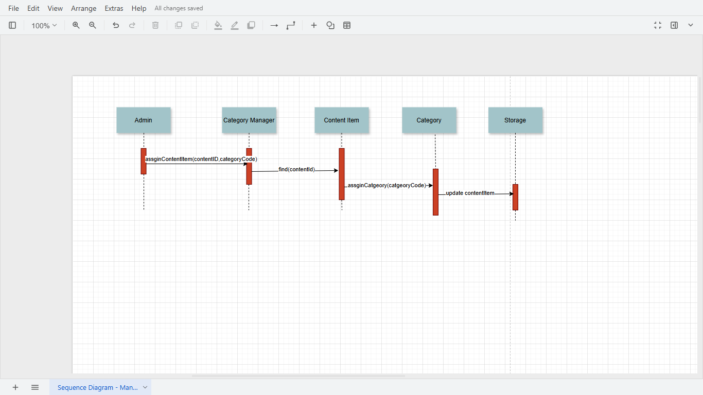

Workflow Implementation
Workflow 1: Manage Content Categories
This workflow allows an admin user to:
- Log in to the system.
- View existing content categories (with their codes and descriptions).
- Create a new content category by specifying a unique code and description.
- Assign a digital content item (identified by its Content ID) to a category.
- Edit an existing category’s description, with a confirmation warning.
Steps Implemented:
- The system uses a simple console-based menu for admin interaction.
- Admin can:
  - List all categories.
  - Add new categories.
  - Assign content items to categories.
  - Edit category descriptions.
- The system ensures no deletion of categories, as per requirements.
Pattern usage
1.Singleton Pattern
The Singleton Pattern is used in the CategoryManager class to ensure that only one instance of this class exists throughout the application. This pattern guarantees that all parts of the system interact with a single, consistent source of truth for managing content categories, preventing inconsistencies and ensuring centralized control.
2.Proxy Pattern
The Proxy Pattern is implemented through the CategoryManagerProxy class, which acts as an intermediary between the Admin user and the CategoryManager. This proxy controls access to the real manager by handling tasks like authentication, authorization, or logging before allowing operations such as creating or updating categories. This design enhances system security and maintainability.
3.Observer Pattern
The Observer Pattern is utilized through the Observer interface and an AdminObserver class that listens for changes in the system. The CategoryManager notifies all registered observers whenever a significant event occurs—such as a category being created or updated. This pattern decouples the notification logic from the core business logic, promoting scalability and flexibility in how the system handles notifications.
Test Case Id | Test Case Description | Test Steps | Test Data | Expected Result | Actual Result | Status
TC-01 | Verify Admin login functionality | 1. Launch app  2. Enter admin credentials  3. Click 'Login' | Username: admin  Password: admin123 | Admin is logged in successfully | As expected | Pass
TC-02 | View existing categories | 1. Navigate to 'Main Operations' screen  2. Click 'View Categories' | N/A | Existing categories are displayed | As expected | Pass
TC-03 | Create a new content category | 1. Navigate to 'Main Operations'  2. Click 'Create Category'  3. Enter valid code and description  4. Click 'Save' | Code: CAT001  Description: Fiction | Category is created successfully and visible in the list | As expected | Pass
TC-04 | Assign a content item to a category | 1. Navigate to 'Assign Content Item'  2. Enter content ID  3. Select category  4. Click 'Assign' | Content ID: C001  Category Code: CAT001 | Content item is assigned to the category | As expected | Pass
TC-05 | Edit category description | 1. Navigate to 'Main Operations'  2. Select edit category  3. Update description  5. Click 'yes' | Updated Description: Updated Fiction | Category description is updated with confirmation | As expected | Pass

